East Coast Canine Inc.
K9 Legal Update
Date: June 15, 2026 Time: 0900–1700 hrs
Fee: Waived for Law Enforcement Officers
Instructor
John M. Peters is a licensed U.S. attorney with more than forty years of trial and appellate experience in police litigation. For over sixteen years, Mr. Peters has instructed police canine handlers, supervisors, and associations nationwide and internationally. His instruction blends real-world legal application with working dog experience, making his courses among the most respected in the field.
Representative Topics Covered
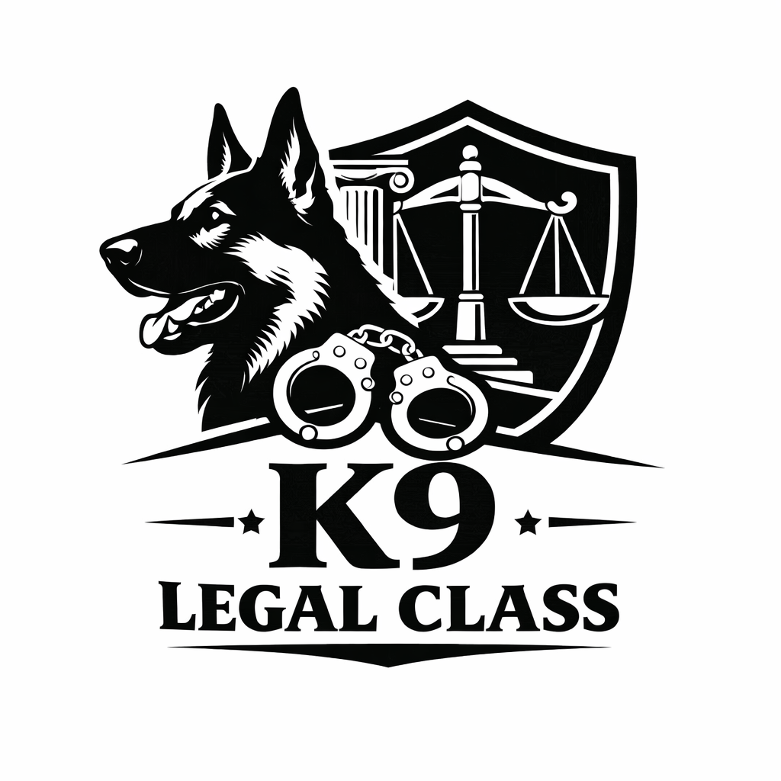
• Fourth Amendment Overview
• Avoiding and Defending Civil Lawsuits
• K9 Search and Seizure
• K9 Use of Force
• Tracking Evidence
• K9 Supervisory Issues
• Cannabis Legalization and K9 Operations
• K9 Record Keeping and Report Writing
• K9 Certification and Training Issues
• Testimony Guidelines
Location
Edgecombe Community College
2009 W. Wilson Street
Tarboro, NC 27886
Registration & Contact
Contact: Tim Braddy
Cell: 252-813-2543Email: eastcoastcanine@gmail.com
Online Registration: www.eastcoastcanineinc.com/register

